LAB 02 TASKS

1)

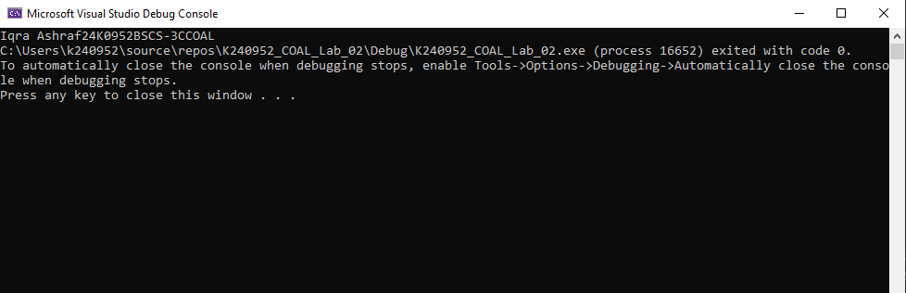

SECTION 3

1)

i.

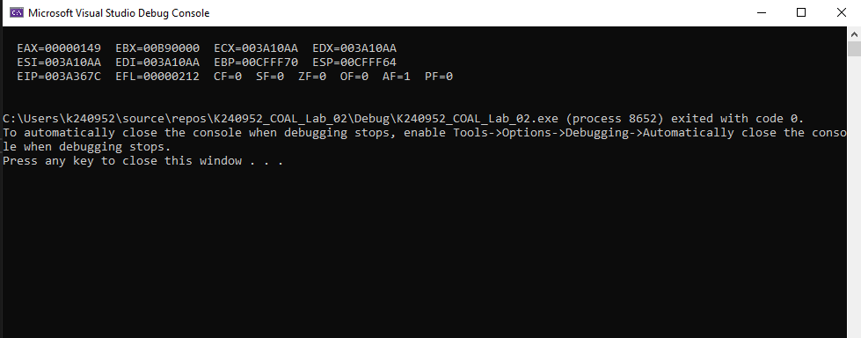

ii.

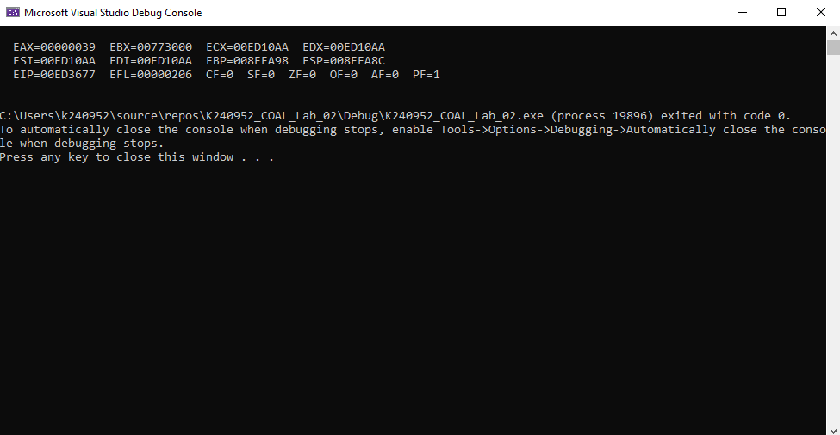

iii.

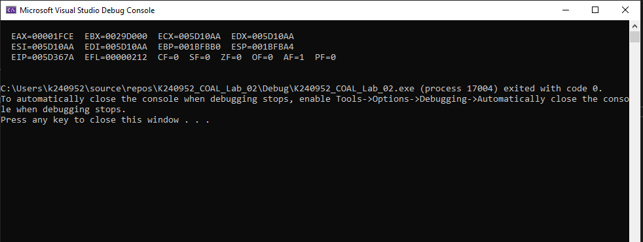

iv.

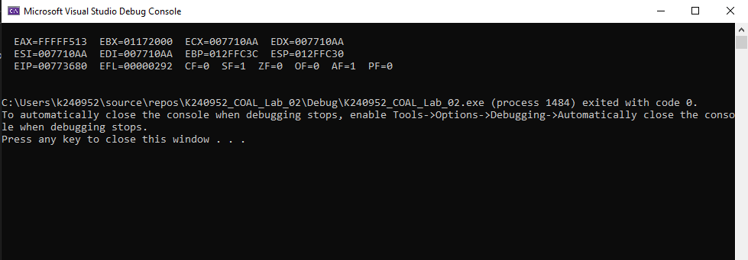

2)

i.

ii.

iii.

iv.

